2D Moving Average Models for Texture Synthesis and Analysis
Zeyu Liu
Professor Kie B. Eom
ECE 6845
May 13, 2019
The George Washington University

Background
This project idea comes from the journal paper “2D moving average models for texture synthesis and analysis”, and understand the model, image synthesis algorithm and parameter estimation algorithm. Implement image synthesis algorithm and reproduce the results presented in the paper.
Introduction
Nowadays, there are many natural textures around us. Texture models have many advantages and are widely used, such as two-dimensional time series models, such as synchronous autoregressive or long correlation models. In this paper, Professor Kie B. EOM proposed a new two-dimensional moving average model for texture synthesis and analysis. From the results, it can be seen that the images synthesized by this model are similar to the original images, so it has great application value.
Texture synthesis and analysis has become one of the most popular and important research fields in the field of image processing. Texture synthesis has many practical applications. It can be used to fill holes in images, reduce image noise, create large non-repetitive background images in PS, and expand small images.
Image and Texture analysis needs to learn relevant algorithms. Given an image, image features, i.e. model type (recognition) and parameter (estimation), are extracted. Then the relevant algorithm is applied to adjust the parameters. Finally, a relatively satisfactory result is given.

Theoretical model
- The Classification of Texture
Textures can be classified as structured(isotropic) texture and stochastic texture based on whether they have structural patterns. Both isotropic and anisotropic textures are used in this experiment. In this paper, professor Eom used different ways to test the two kinds of textures. The experiment and discussion are classified by these two kinds of textures.
For isotropic textures, using the estimated parameters, textures are synthesized using white complex Gaussian process W(u).
For anisotropic textures, Using the estimated parameters, textures resembling the original textures are synthesized using white complex Gaussian process W(u).
The MA model is applicable to structured textures by using structured residual process w(s). If the residual process contains structured information, the synthesized image will exhibit structural patterns. To find the residual is the most important thing to the anisotropic textures.

- 2-D Moving Average Model
This is the basic 2-D moving average (MA) model, the texture can be modeled by the process as flow chart below.

Y (u)=NG(u)W(u)
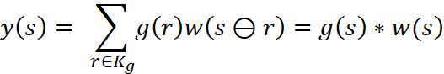
DFT

In the paper, the FIR filter is assumed to be a linear geometric transform of the anisotropic filter. Thus, the FIR filter is described by isotropic MA parameters and two geometric transform parameters. The two geometric parameters called elongation and orientation parameters. (alpha and theta)

This model can be represented by the following convolution equation:
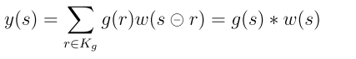 (1)
w(s) is a 2-D white Gaussian process with zero mean and unit variance.
The ML estimator of 2-D model parameters are derived in the frequency domain, so we need to apply DFT to both sides of (1).
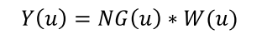 (2)
Another important thing needs to be known is the geometric matrix A, where
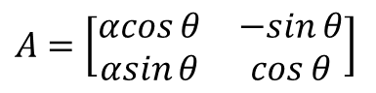 (3)
Assume that the transfer function G(u) can be obtained by a linear geometric transform of an isotropic function, and the equation (2) can be rewritten as
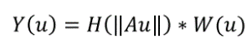 (4)

- Parameter Estimation
The estimated parameters represent the characteristics of the texture well. When we analyze a texture using an image model, we need to estimate the parameters from the observed image. And in this paper, we use maximum likelihood (ML) estimation of MA parameters in the frequency domain.
When the orientation and elongation parameters are known, the ML estimator of ŋi can be expressed by
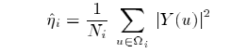 (5)
And another important equation is the cost function J(θ,α) :
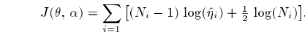(6)

Algorithm
- Estimation Algorithm
- Apply the DFT to the image and obtain Y(u);
- For each θ∈Θ and α∈A, estimate parameters{ ŋ_{i,} I,…,n} using the equation (5);
- Using the estimated parameters {ŋ_{i}, I,…,n}, compute the cost function J(θ,α) based on the equation (6) for each θ∈Θ and α∈A;
- We can get the ML estimators and by minimizing J(θ, α) with respect to θ∈Θ and α∈A.
When elongation parameter α = 1, the synthesized image becomes isotropic. Next algorithm shows a texture can be synthesized from a complex white Gaussian random field. And the texture synthesis using 2-D MA model is done in the frequency domain.
Here is the image synthesis algorithm:
- Specify the value of MA parameters H, and geometric transform parameters θ，α，and β. For synthesizing an isotropic image, the geometric transform parameters are initialized by θ = 0, α = 1 and β = 1;
- Generate 2-D complex white Gaussian sequence {W(u)|u∈Ω_{u}} having zero mean and covariance matrix (N/2)I;
- Replace W(0,0) bywhere is the sample mean of y(s), and construct W(u1,u2) using the symmetry relation of DFT;
- For each u∈Ω，Y(u) is obtained by the following equation.
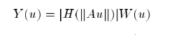 (7)
- The synthesized image in the spatial domain is obtained by applying IDFT to Y(u).

Experimental Results
In the class, we know that textures can be decomposed into deterministic and stochastic components. We can classify them based on the deterministic trend. Stochastic textures are the textures without any deterministic trend and are modeled well by 2-D MA model with uncorrelated residual process w(s). Structured textures have a strong deterministic trend and can be modeled with the structured residual process under the 2-D MA model. Like homework 5, use the new parameters we found from cost function: alpha and theta. Do geometric transform, then white Gaussian process, and then IDFT.
I use MATLAB to reproduce the results in the paper.

- Stochastic Textures(isotropic)
Using the equation (7), the textures can be synthesized by estimators and white complex Gaussian process. Isotropic textures can be modeled by 2-D MA model as a special case when elongation parameter is unity. Assuming the image is isotropic, and the parameters can be estimated by the ML method. As mentioned above, the ML estimators and can be obtained by minimizing J(θ, α) with respect to θ ∈θ and α ∈A.
we need to find Y(u), we need to find ML estimator.
Step 1: Read the image texture y and apply DFT to it get Y:
Step 2: Apply the geometric transform to the Y and obtain the YU:
Step 3: Using equation (5) to find the ML estimator:
Step 4: Using the equation (6), we can get the cost function and it needs to be minimized so that the ML estimators and can be obtained. In this step, we need the for loop, because θ and α can be discretized to the finite set: θ = {kπ/8, k = 0,…,7} and A = {1,2,…,8}. write cost function and minimize it,
Step 5: The α and θ have already been obtained from the former steps so we can apply the geometric transform to Y based on the parameters we find, and we can find estimated ŋi.
Step 6: Generate 2-D complex white Gaussian sequence w which has zero mean and covariance matrix (N/2)I.After that Y(u) can be obtained by equation (7).
Step 7: The synthesized image in the spatial domain can be obtained by applying IDFT to Y(u).
The result images are using 2-D MA models with estimated parameters and white Gaussian input.
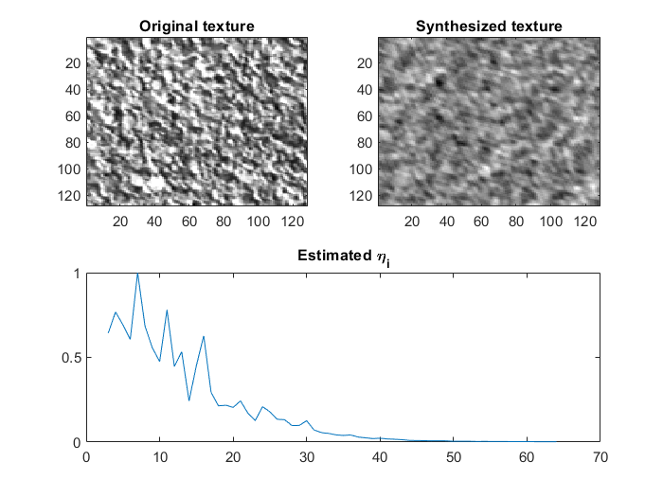
Figure 1 D04
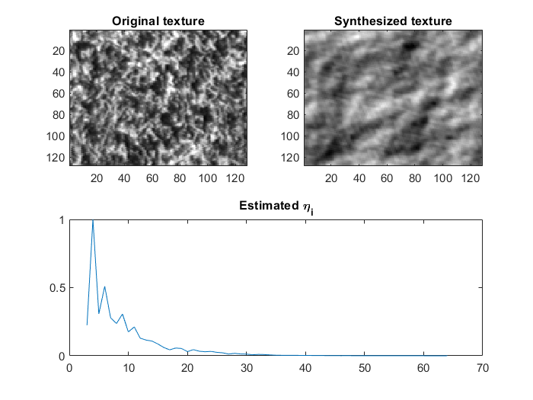
Figure 1 D09
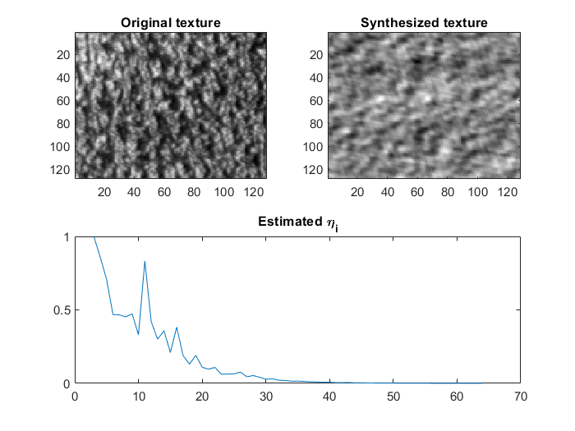
Figure 2 D024
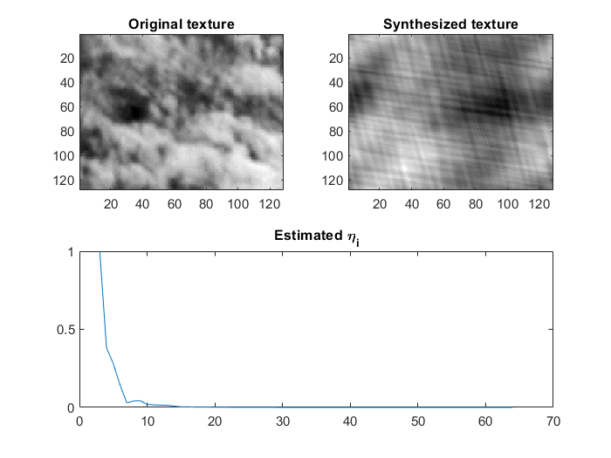
Figure 3 D90
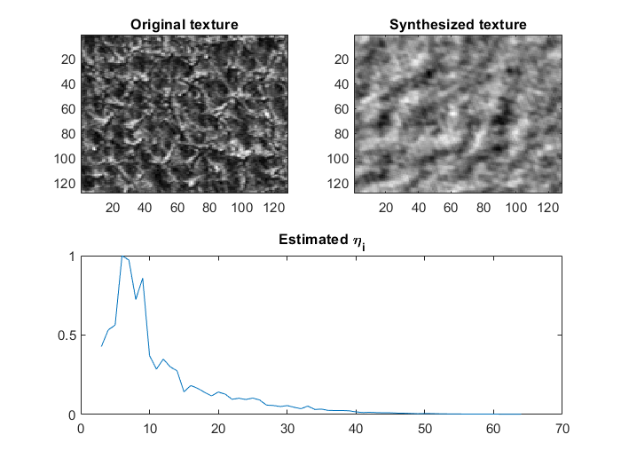
Figure 4 D92

- Structured Textures (anisotropic)
The process of synthesizing the structured textures is different from synthesizing the stochastic textures because the structured textures have a strong deterministic trend and cannot be modeled with a random field model, they should be modeled by 2-D MA model with the structured residual process. If the structured textures still modeled with a random excitation process such as a white noise process, the images after synthesizing will not exhibit the structured patterns.
If we want to synthesize the structured textures with the residual process, we need to think about each texture. For each texture, the model parameters are estimated and the frequency domain residual process is computed by

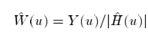 (8).
For the isotropic textures have circular symmetric correlation structures, we can synthesize the 128*128 textures based on the 64*64 textures.
The results pictures of synthesis of structured textures are exhibited as following, 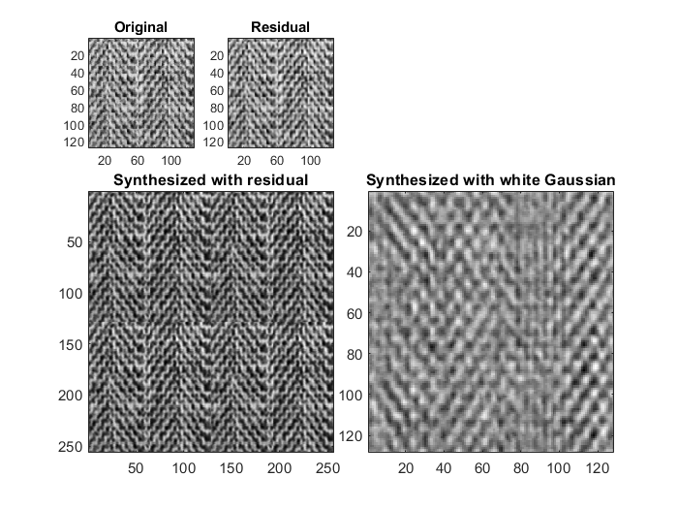
Figure 5 D17 synthesized with residual and Gaussian
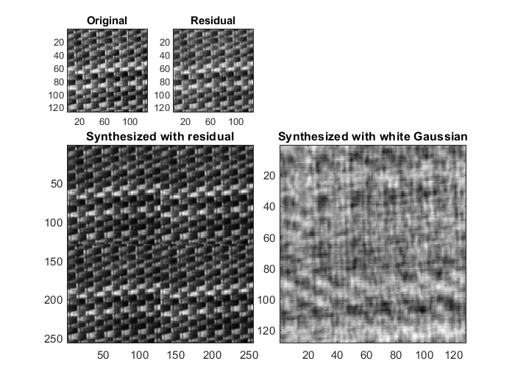
Figure 6 D55 synthesized with residual and Gaussian input
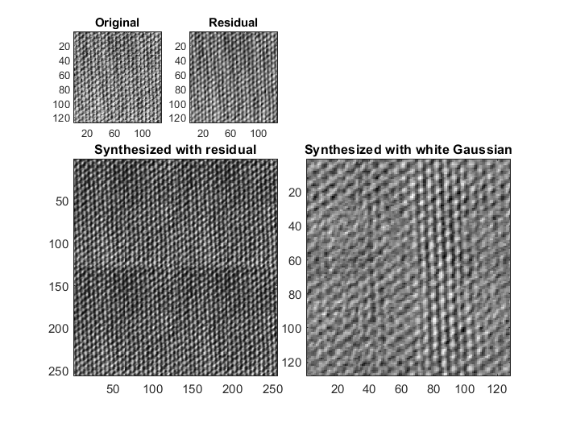
Figure 7 D77 synthesized with residual and Gaussian input
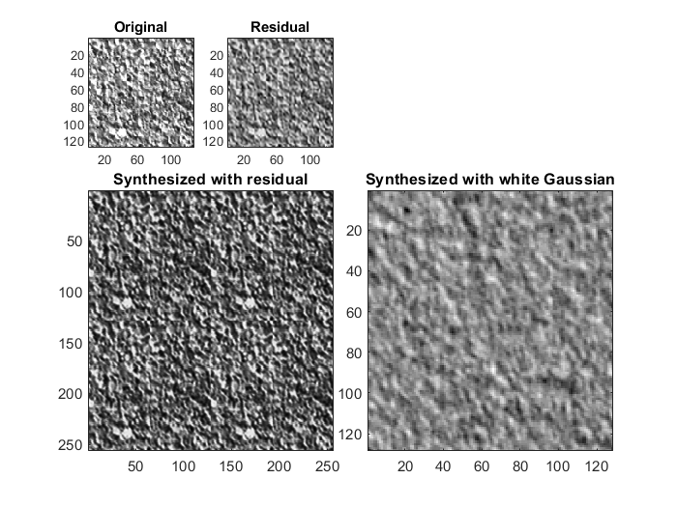
Figure 8 D04 synthesized with residual and Gaussian input

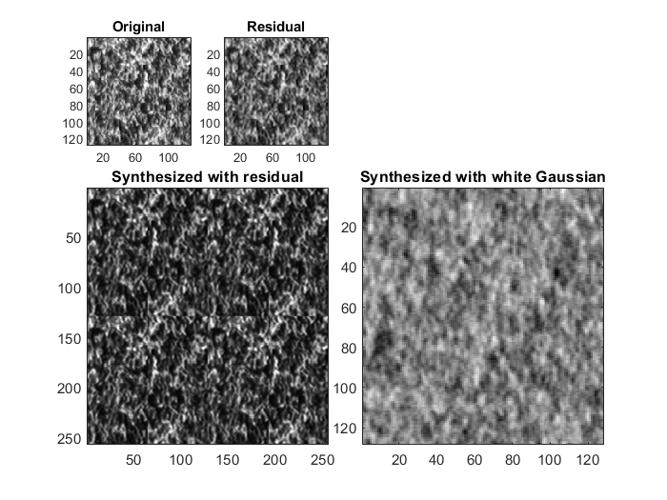
Figure 9 D09 synthesized with residual and Gaussian input
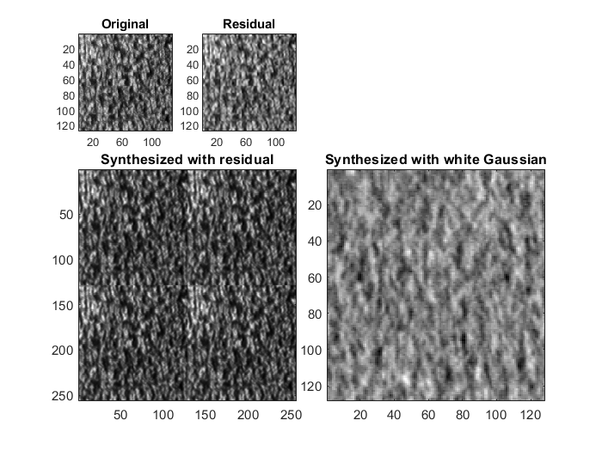
Figure 10 D24 synthesized with residual and Gaussian input
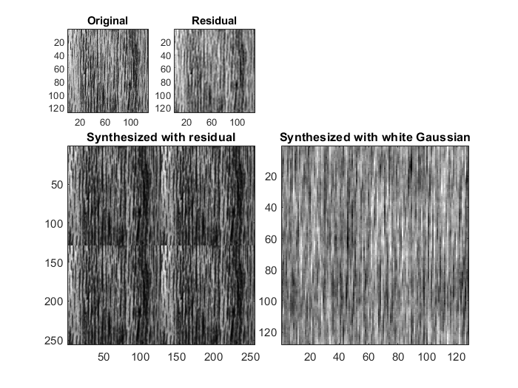
Figure 11 D68 synthesized with residual and Gaussian input
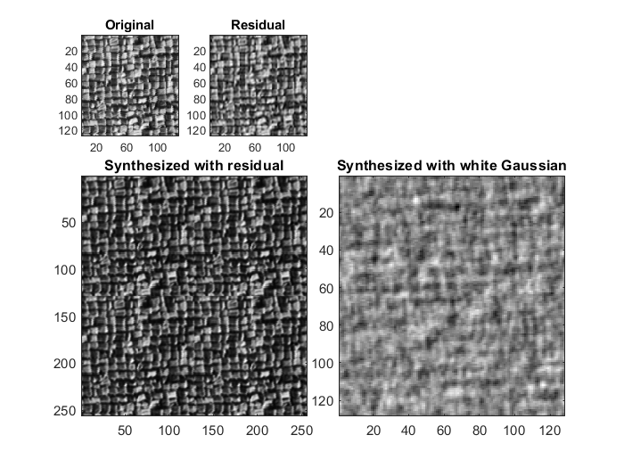
Figure 12 D84 synthesized with residual and Gaussian input

Conclusion
Through this class, I learned about 2-D moving average models for texture synthesis and analysis. The model has a certain flexibility, through which relevant parameters can be obtained. With these parameters, there are many textures similar to real natural textures can be synthesized. These features are very intuitive. Random texture and structured texture can be synthesized by using these parameters.
Texture image synthesis is carried out in the frequency domain. In the random texture experiments, it can be concluded that natural texture images can be synthesized by a white complex Gaussian image multiplies the extracted parameters. The synthesized images are very similar to the original images.
The structural texture synthesis method is different from the random texture. It should be synthesized using structured residual processes. In the absence of structured residual input, the synthesized image cannot present a structured pattern, but it is still similar to the original image. Therefore, we can conclude that the image synthesized by estimating model parameters and structured residuals is similar to the original image.
Compared with the results of Professor Eom's paper, my experimental results are quite erroneous. I don't think my synthesized image is very similar to the original image. This may be a problem in the implementation of the algorithm. Because the article does not fully explain how to quantify and truncate residuals and how the residuals process can be sampled by factors.
Although I finally got some results, I think I can do some improvement. Through this project, I understand how to read a paper carefully and completely, and also understand its ideas and methods. This skill is very important for researchers. I hope I have the opportunity to challenge different projects again in the future.
Reference
K.B. Eom, “2D moving average models for texture synthesis and analysis,” IEEE Trans. on Image Processing, vol. 7, no. 12, pp. 1741-1746, December 1998.

Appendix
function MovingAverage_Models
[x,cmap]=imread('D04.hips.gif'); % Choose D04 D09 D90 D92 D24
colormap(cmap);
[M,N] = size(x);
y=zeros(size(x));
for m=1:N
for n=1: N
c = cmap(x(m,n)+1);
y(m,n) = c(1);
end
end
[N,M] = size(y);
Y = fft2(y);
colormap(gray(256));

% White complex Gaussian process(actually use randn(N) is ok, but this way is better)
mu=randn(1,N);
sigma = N/4*eye(N);
R = chol(sigma);
w = repmat(mu,N,1) + randn(N)*R;
%construct with 0 mean (N/4)I covariance real part(same as before)
mui=randn(1,N);
sigmai = N/4*eye(N);
Ri = chol(sigmai);
wi = repmat(mui,N,1) + randn(N)*Ri;
W=w+sqrt(-1)*wi;
W1 = fft2(W);
W = fftshift(W1);

W(1,1)=N*mean(mean(y(1:N,1:N))); % Change W(0,0)
%Parameters initialize
%elongation alpha =[1,2,3,4,5,6,7,8];
%orientation theta = [0,pi/8,2*pi/8,3*pi/8,4*pi/8,5*pi/8,6*pi/8,7*pi/8]
Ni = 1:N;
Nparameter=128;
Eta=zeros(Nparameter,N);
Jcost=zeros(3,Nparameter); %cost function 3 parameter

%Cost Function
a=1;
for alpha = 1:8
for theta = 0:pi/8:7*pi/8
YU = gtrans(Y,alpha,theta);
Eta(a,:) = ML_estimator(N,YU);

Jcost(2,a) = alpha;
Jcost(3,a) = theta;
for i=2:N/2
if(Eta(a,i)~=0)
Jcost(1,a)=Jcost(1,a)+(Ni(a)-1)*log(Eta(a,i))+1/2*log(Ni(a));
end
end
a = a+1;
end
end

%Minimize the cost function to obtain the alpha and theta
[~,Costmin]=min(Jcost(1));
alpha=Jcost(2,Costmin);
theta=Jcost(3,Costmin);
%After obtained the parameters, apply gtrans to Y
YU = gtrans(Y,alpha,theta);
Eta(1,:) = ML_estimator(N,YU);
max_eta=max(Eta(1,3:N/2));
estimated=Eta(1,3:N/2)/max_eta;
%Synthesize
YY=zeros(N,N);
for i=1:N,
for m=1:N,
for n=1:N,
radius=hypot(m,n);
if (radius>(i-1))&&(radius<=i),
YY(m,n)=Eta(1,i);
end
end
end
end

YY=abs(YY).*W;
yy=ifft2(YY);
%image(abs(YY));
%pause;
colormap(gray(256));
subplot(2,2,1),imagesc(y);
title('Original texture');

c = fspecial('gaussian',3,3);% I use gaussian filter to make the result better
yy = imfilter(yy,c);
subplot(2,2,2),imagesc(real(yy));
title('Synthesized texture');

subplot(2,2,[3,4]),plot(3:N/2,estimated);
title('Estimated \eta_i');
end

function MovingAverage_residual
[x,cmap]=imread('D24.hips.gif'); % choose D17,D55,D77,D84,D68,D04,D09,D51,D68,D24
colormap(cmap);
[M,N] = size(x);
y=zeros(size(x));
for m=1:N
for n=1: N
c = cmap(x(m,n)+1);
y(m,n) = c(1);
end
end
[N,M] = size(y);
Y = fft2(y);
colormap(gray(256));
Eta=ML_estimator(N,Y);
r=Y./norm(Eta);

WI =[r(1:32,1:32).*2,0.00*randn(32,64),r(1:32,97:128).*2;0.00*randn(64,32),0.00*randn(64,64),0.00*randn(64,32);r(97:128,1:32).*2,0.00*randn(32,64),r(97:128,97:128).*2];
% residual
%imagesc(real(WI));
Wi=ifft2(WI);
%imagesc(real(Wi));

Ni=1:64;
a=1;
Jcost=zeros(3,N);
Eta=zeros(1,N);
norm_eta=zeros(N,N);
%Cost function
for alpha=1:8
for theta=0:pi/8:7*pi/8
YU=gtrans(Y,alpha,theta);
Eta(a,:)=ML_estimator(N,YU); % H
max_eta=max(Eta(a,3:N));
norm_eta(a,3:N)=Eta(a,3:N)/(max_eta);
Jcost(2,a)=alpha;
Jcost(3,a)=theta;
for i=1:128
if (Eta(a,i)~=0) % Eta(p,i)!=0
Jcost(1,a)=Jcost(1,a)+(Ni(a)-1)*log(Eta(a,i))+1/2*log(Ni(a));
end
end
a=a+1;
end
end

[~,Costmin]=min(Jcost(1));
alpha=Jcost(2,Costmin);% alpha
theta=Jcost(3,Costmin);% theta

YU=gtrans(Y,alpha,theta);
Eta(1,:)=ML_estimator(N,YU);
%synthesize
YY=zeros(N,N);
for i=1:N
for m=1: N
for n=1: N
radius=hypot(m,n);
if (radius>(i-1)&&(radius<=i))
YY(m,n)=Eta(1,i);
end
end
end
end

% White complex Gaussian process(actually use randn(N) is ok, but this way is better)
mu=randn(1,N);
sigma = N/4*eye(N);
R = chol(sigma);
w = repmat(mu,N,1) + randn(N)*R;
%construct with 0 mean (N/4)I covariance real part(same as before)
mui=randn(1,N);
sigmai = N/4*eye(N);
Ri = chol(sigmai);
wi = repmat(mui,N,1) + randn(N)*Ri;
W=w+sqrt(-1)*wi;
W1 = fft2(W);
W = fftshift(W1);

W(1,1)=N*mean(mean(y(1:N,1:N))); % Change W(0,0)

YY=abs(YY).*W;
yy=ifft2(YY);

subplot(3,4,1),imagesc(y);
title('Original');

subplot(3,4,2),imagesc(real(Wi));
title('Residual');

s = y.*Wi;
s = repmat(s,2,2);
subplot(3,4,[5,6,9,10]),imagesc(real(s));
title('Synthesized with residual');

yy= ifft2(Y.*W)
subplot(3,4,[7,8,11,12]),imagesc(real(yy));
title('Synthesized with white Gaussian');

function Eta = ML_estimator(N,YU)
YUS = zeros(1,N);
Eta = zeros(1,N);
Ni = 1:N;
for i=1:N,
for m=1:N
for n=1:N
distance=round(hypot(m,n));
if (distance>(i-1))&&(distance<=i)
YUS(i)=YUS(i)+(abs(YU(m,n)))^2;
end
end
end
Eta(i)=YUS(i)/Ni(i);
end
end
function y = gtrans(x, alpha, theta)

y = zeros(size(x));
N = length(x(1,:));

for m=1:N
for n=1:N
if (m>N/2)
m1 = m-1-N;
else
m1 = m-1;
end
if (n>N/2)
n1 = n-1-N;
else
n1 = n-1;
end
r = round(1/alpha*cos(theta)*m1 - sin(theta)*n1);
s = round(1/alpha*sin(theta)*m1 + cos(theta)*n1);
if (s<0)
s=N+s;
end
if (r<0)
r=N+r;
end
if ((r>=0) && (s>=0) && (r<N) && (s<N))
y(m,n) = x(r+1,s+1);
end
end
end

